EXP 2: Design and Implementation of VLAN Segmentation and Inter-VLAN Routing for a Multi-Department Network using Cisco Packet TracerMajor

- To create and configure Virtual Local Area Networks (VLANs) for logical network segmentation and traffic isolation.

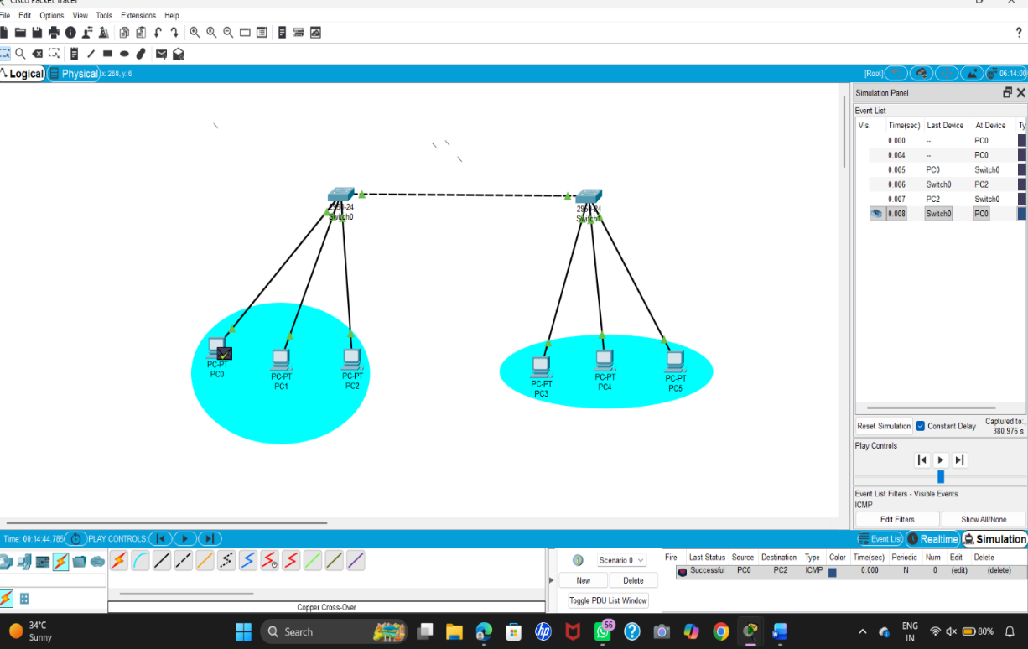

(ii) To configure Inter-VLAN Routing to enable communication between devices belonging to different VLANs.

